Fra www.gronnkirke.no /Ressurser/Litteratur

Litteratur om økoteologi, miljø, forbruk og rettferd på engelsk
Det meste av litteraturen listet her er hentet fra nettsiden http://www.creationcare.org/ og kan bestilles online direkte fra http://astore.amazon.com/creacare-20

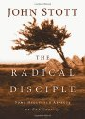 | 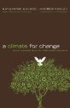 | 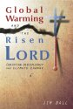
The Radical Disciple: Some Neglected Aspect...  by John Stott  $12.50  What is a life of radical discipleship? At root, it means we let Jesus set the agenda of our lives. We aren't selective. We do... | A Climate for Change: Global Warming Facts ...  by Katharine Hayhoe  "This engaging book has everything you need to understand the climate change debate: facts, answers, stories, and of course Sc... | Global Warming and the Risen LORD: Christia...  by Jim Ball  Global Warming and the Risen LORD moves beyond the old debates about climate change to a new conversation focusing on the trem...
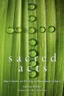 |  | 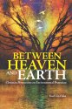
Sacred Acts: How Churches are Working to Pr...  by Mallory McDuff  $13.17  With a chapter from EEN's President Mitch Hescox this book covers stories from across North America of contemporary church lea... | Pollution and the Death of Man  by Francis A. Schaeffer  $13.76  At the creation of the world, God gave mankind the responsibility to exercise dominion over the earth. Man was to use the eart... | Between Heaven and Earth: Christian Perspec...  by Fred Van Dyke  $40.46  There are many books on Christian environmental ethics, but none provides a clear and thorough analysis of the history of the ...
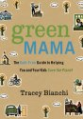 | 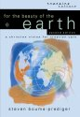 | 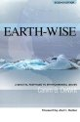
Green Mama: The Guilt-Free Guide to Helping...  by Tracey Bianchi  $10.17  Writer and speaker Bianchi does what few evangelicals have the courage or social insight to accomplish, treading fearlessly in... | For the Beauty of the Earth: A Christian Vi...  by Steven Bouma-Prediger  $18.01  Caring for the environment is a growing interest among evangelicals. This award-winning book provides the most thorough evange... | Earth-Wise: A Biblical Response to Environm...  by Calvin B. Dewitt  Christians play a crucial role in maintaining the environment as stewards of God's creation. Calvin B. DeWitt, a nationally re...
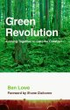 | 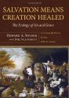 | 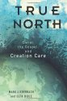
Green Revolution: Coming Together to Care f...  by Ben Lowe  $13.10  "I am grateful for Ben Lowe's book. Green Revolution is an invitation, not just to believe that another world is possible, but... | Salvation Means Creation Healed: The Ecolog...  by Howard A. Snyder  $27.48  The Bible promises the renewal of all creation--a new heaven and earth--based on the incarnation, life, death, and resurrectio... | True North: Christ, the Gospel, and Creatio...  by Mark Liederbach  $14.99  Because the Bible describes the second person of the Trinity as the key agent in creation, redemption, and the restoration of ...
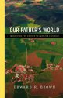 | 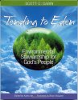 | 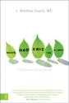
Our Father's World: Mobilizing the Church t...  by Edward R. Brown  $13.28  Edward Brown offers a biblical framework for creation care as well as practical steps that ordinary Christians can take to exe... | Tending to Eden: Environmental Stewardship ...  by Scott C. Sabin  $12.37  This is a highly personal approach to educating and inspiring today's evangelical church to think biblically, locally, and int... | Serve God, Save the Planet: A Christian Cal...  by Matthew Sleeth M.D.  $12.68  '...a great read on how individual Christians and their families can respond to God's call for environmental stewardship.' -- ...
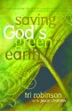 | 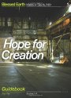 | 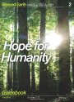
Saving God's Green Earth  by Tri Robinson  For hundreds of years, the church championed the beauty of God’s creation, demonstrating in many ways how it points to the Cre... | Hope for Creation Guidebook: Part One (Bles...  by Matthew Sleeth M.D.  $4.00  'Following Jesus is good for the planet. Or should be, at least. This is the radical, yet solidly biblical premise of Blessed ... | Hope for Humanity Guidebook: Part Two (Bles...  by Matthew Sleeth M.D.  $8.95  'Following Jesus is good for the planet. Or should be, at least. This is the radical, yet solidly biblical premise of Blessed ...
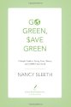 | 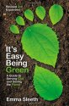 | 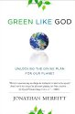
Go Green, Save Green: A Simple Guide to Sav...  by Nancy Sleeth  $9.94  Many people want to “go green” but put it off because they believe it's too time consuming and too expensive. Not so! Nancy Sl... | It's Easy Being Green, Revised and Expanded...  by Emma Sleeth  $8.99  Help make the world a greener place! Join author Emma Sleeth as she explores the theology behind creation care and suggests p... | Green Like God: Unlocking the Divine Plan f...  by Jonathan Merritt  "In this debut book, Jonathan Merritt brings together biblical integrity, Christian humility, and social sensitivity in a call...
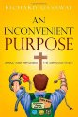 | 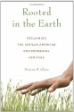 | 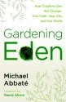
An Inconvenient Purpose: Linking Godly Stew...  by Richard Gasaway  $22.46  Gasoline and electricity are crucial to everyone's lives, but few think beyond the economics of energy. However, national secu... | Rooted in the Earth: Reclaiming the African...  by Dianne D. Glave  With a basis in environmental history, this groundbreaking study challenges the idea that a meaningful attachment to nature an... | Gardening Eden: How Creation Care Will Chan...  by Michael Abbate  Before the snake, the apple, and the Ten Commandments, God created a garden… “Spiritual environmentalism” did not start ...
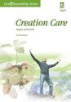 | 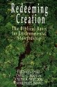 | 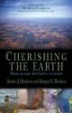
Creation Care: Keepers of the Earth (Living...  by Luke Gascho  How can Christians put their faith into practice on issues like air and water quality, energy use, and the climate? Designed f... | Redeeming Creation: The Biblical Basis for ...  by Fred H. Van Dyke  $16.20  "Preeeeep." The sound of the peepers, tiny frogs an inch or two long, penetrated the dusk. Beneath the jack pines at the edge ... | Cherishing the Earth: How to Care for God's...  by Martin J. Hodson  $6.00  Drawing on stories of people who have found positive ways to respond to the state of the earth, Martin and Margot Hodson show ...
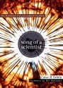 | 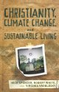 | 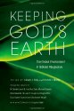
Song of a Scientist: The Harmony of a God-S...  by Calvin B DeWitt  $14.39  World-renowned environmental scientist Cal DeWitt is widely regarded as a pioneer in opening the eyes of the Christian communi... | Christianity, Climate Change, and Sustainab...  by Nick Spencer  Spencer, White, and Vroblesky offer serious Christian engagement with the emerging issue of Sustainable Consumption and Produc... | Keeping God's Earth: The Global Environment...  $21.92  Diversity of life. Water resources. Global climate change. Cities and global environmental issues. We all know being a Christi...
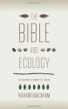 | 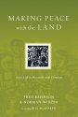 | 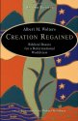
The Bible and Ecology: Rediscovering the Co...  by Richard Bauckham  With his characteristic rigor and perceptiveness, Richard Bauckham embarks on a Biblical investigation into the relationship o... | Making Peace with the Land: God's Call to R...  by Fred Bahnson  $12.71  Making Peace with the Land: God's Call to Reconcile with Creation | Creation Regained: Biblical Basics for a Re...  by Albert M. Wolters  $11.63  In print for two decades and translated into eight languages, Albert Wolterss classic formulation of an integrated Christian w...
 |  | 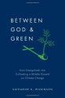
Between God & Green: How Evangelicals A...
by Katharine K. Wilkinson
$26.66
Despite three decades of scientists' warnings and environmentalists' best efforts, the political will and public engagement ne...

